**DOCTORAL PROGRAM IN MANAGEMENT 2024**

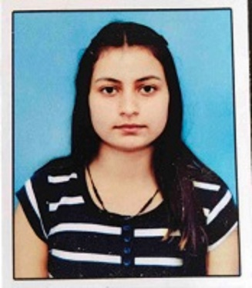

**Name: Yashika Bhardwaj**

**Area: Organisational Behaviour and HRM**

**Email ID:** [**d24yashikab@iimidr.ac.in**](mailto:d24yashikab@iimidr.ac.in)

**Contact: +91 – 8580639919**

**LinkedIn:** [**https://www.linkedin.com/in/yashika-bhardwaj-42620a219**](https://www.linkedin.com/in/yashika-bhardwaj-42620a219)

|  |  |  |
| --- | --- | --- |
| **EDUCATIONALQUALIFICATIONS** | | |
| **Qualification** | **Institute** | **Year** |
| MBA (BANKING AND INSURANCE MANAGEMENT) | University Institute of Applied Management Sciences, Punjab University, Chandigarh | 2022 |
| BACHELOR’S DEGREE  IN COMMERCE | Government Degree College, Sanjauli, Shimla | 2020 |

**EXPERIENCE**

OUTLOOK PUBLISHING INDIA PVT. LTD., DELHI – INTERNSHIP

(JULY-SEPT 2021)

ANALYSIS INTERN

**CERTIFICATION**

* E-COMMERCE (1 YEAR COURSE)
* MS-OFFICE AND PHOTOSHOP (6 MONTHS)
* NATIONAL SERVICE SCHEME (NSS) – A GRADE
* UGC NET QUALIFIED IN HRM– JUNE 2023
* UGC – NET/ JRF QUALIFIED IN MANAGEMENT – DEC 2023

**AREAS OF INTEREST**

* Psychological Contracts
* Mindfulness
* Workplace Spirituality